Use case summary

|  |  |
| --- | --- |
| **Use Case Name** | **Use Case Number** |
| Member Register | MMS-001 |
| Administrator Register | MMS-002 |
| User Login | MMS-003 |
| Search/View Member Information | MMS-004 |
| Edit Member Information | MMS-005 |
| Delete Member | MMS-006 |
| View User Information | MMS-007 |
| Edit User Information | MMS-008 |
| View Friend List | MMS-009 |
| Delete Friend | MMS-010 |
| Find Friend | MMS-011 |
| Send Friend Request | MMS-012 |
| Accept Friend Request | MMS-013 |
| Delete Friend Request | MMS-014 |
| Send Personal Message | MMS-015 |
| View Personal Message | MMS-016 |
| Delete Personal Message | MMS-017 |
| Search/View Dining Event Information | DES-001 |
| Delete Dining Event | DES-002 |
| Create Dining Event | DES-003 |
| Join Dining Event | DES-004 |
| Give Dining Event Comment | DES-005 |
| Dining Event Alert | DES-006 |
| Search/View Restaurant Information | RCS-001 |
| Create Restaurant Record | RCS-002 |
| Edit Restaurant Record | RCS-003 |
| Delete Restaurant Record | RCS-004 |
| Give Restaurant Comment | RCS-005 |
| Delete Restaurant Comment | RCS-006 |
| Create Discount Coupon | RCS-007 |
| Edit Discount Coupon | RCS-008 |
| Delete Discount Coupon | RCS-009 |
| Get Discount Coupon | RCS-010 |
| View Owned Discount Coupon | RCS-011 |
| Contact Us | RCS-012 |

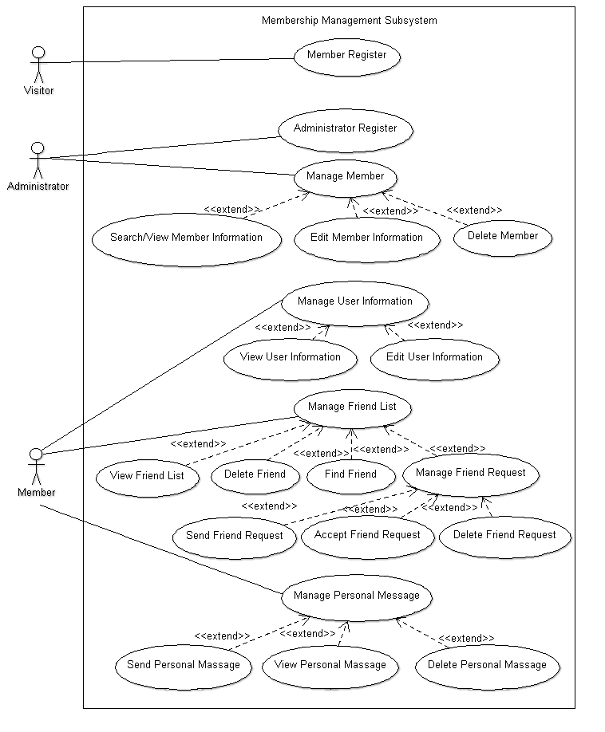

|  |  |
| --- | --- |
| Use case name | Member Register |
| Use case ID | MMS-001 |
| Super use case | - |
| Actor(s) | Visitor |
| Brief description | Visitor register as member |
| Precondition | Visitor is not member |
| Post-condition | Become a member |
| Flows of events | Register by inputting user name, password, email, phone number, interest, and 2 security question with answer. |
| Alternative flows and exceptions | Any registered user name, email, or phone number will be banned. |
| Priority | High |
| Non-behavioral requirements | Password is encrypted and fulfill the password rule set;  User name cannot include some word (e.g. admin) |
| Assumptions | All input material are correct |
| Issues | - |
| Source | - |

|  |  |
| --- | --- |
| Use case name | Administrator Register |
| Use case ID | MMS-002 |
| Super use case | - |
| Actor(s) | Administrator |
| Brief description | Administrator create another administrator |
| Precondition | Login as administrator |
| Post-condition | Another administrator is created |
| Flows of events | Register by inputting admin name, password, and 2 security question with answer |
| Alternative flows and exceptions | Any registered user name will be banned. |
| Priority | High |
| Non-behavioral requirements | Password is encrypted and fulfill the password rule set |
| Assumptions | All input material are correct |
| Issues | - |
| Source | - |

|  |  |
| --- | --- |
| Use case name | User Login |
| Use case ID | MMS-003 |
| Super use case | - |
| Actor(s) | Member, Administer |
| Brief description | Visitor login to the system |
| Precondition | Visitor has registered |
| Post-condition | Login to the system |
| Flows of events | Input user name and password in the login page |
| Alternative flows and exceptions | 1.1) If input wrong either of it, then request input again  1.2) If wrongly input for 5 times, request input the security question  1.3) If failed to answer the security question, lock the account for 30 minutes  2.1) If forget password, request input the security question  2.2) If failed, output error message. |
| Priority | High |
| Non-behavioral requirements | Password are masked and encrypted |
| Assumptions | - |
| Issues | - |
| Source | - |

|  |  |
| --- | --- |
| Use case name | Search/View Member Information |
| Use case ID | MMS-004 |
| Super use case | - |
| Actor(s) | Administrator |
| Brief description | Administrator search member information |
| Precondition | 1) Login as administrator  2) Select manage member from the administrator home page |
| Post-condition | Retrieve information from the database |
| Flows of events | Administrator input the member’s user name to the search engine |
| Alternative flows and exceptions | 1) If result is found, view member information 2) If result not found, output error message  3) Back to administrator home page |
| Priority | High |
| Non-behavioral requirements | - |
| Assumptions | - |
| Issues | - |
| Source | - |

|  |  |
| --- | --- |
| Use case name | Edit Member Information |
| Use case ID | MMS-005 |
| Super use case | - |
| Actor(s) | Administrator |
| Brief description | Change a member’s Information with reason |
| Precondition | 1) Login as administrator  2) After search information  3) Select edit member information |
| Post-condition | Save changed information |
| Flows of events | 1.1) Select edit member information  1.2) Change the information  1.3) Save  2) Back to administrator home page |
| Alternative flows and exceptions | 1.1) Give up to change the information  1.2) Back to administrator home page |
| Priority | High |
| Non-behavioral requirements | - |
| Assumptions | - |
| Issues | - |
| Source | - |

|  |  |
| --- | --- |
| Use case name | Delete Member |
| Use case ID | MMS-006 |
| Super use case | - |
| Actor(s) | Administrator |
| Brief description | Delete a member’s membership with reason |
| Precondition | 1) Login as administrator  2) After search information  3) Select delete member |
| Post-condition | Deleted friend will not exist anymore. |
| Flows of events | 1) Press delete button  2) Enter administrator password and press confirm delete button |
| Alternative flows and exceptions | 1) Cancel delete  2) Back to administrator home page |
| Priority | Medium |
| Non-behavioral requirements | Password is masked and encrypted |
| Assumptions | - |
| Issues | - |
| Source | - |

|  |  |
| --- | --- |
| Use case name | View User Information |
| Use case ID | MMS-007 |
| Super use case | - |
| Actor(s) | Member |
| Brief description | View user information, interest, and member point |
| Precondition | Login as member |
| Post-condition | Basic information, interest, and member point are output |
| Flows of events | Select view user information from the member home page |
| Alternative flows and exceptions | Back to member home page |
| Priority | High |
| Non-behavioral requirements | Password is masked |
| Assumptions | - |
| Issues | - |
| Source | - |

|  |  |
| --- | --- |
| Use case name | Edit User Information |
| Use case ID | MMS-008 |
| Super use case | - |
| Actor(s) | Member |
| Brief description | Edit user information or interest |
| Precondition | 1) Login as member  2) Selected view user information |
| Post-condition | Save changed information |
| Flows of events | 1.1) Select edit user information  1.2) Change the information  1.3) Save  2) Back to view user information |
| Alternative flows and exceptions | 1.1) Give up to change the information  1.2) Back to view user information |
| Priority | High |
| Non-behavioral requirements | - |
| Assumptions | - |
| Issues | - |
| Source | - |

|  |  |
| --- | --- |
| Use case name | View Friend List |
| Use case ID | MMS-009 |
| Super use case | - |
| Actor(s) | Member |
| Brief description |  |
| Precondition | Login as member |
| Post-condition | Show all friends |
| Flows of events | Select friend from the member home page |
| Alternative flows and exceptions | Back to member home page |
| Priority | High |
| Non-behavioral requirements | - |
| Assumptions | - |
| Issues | - |
| Source | - |

|  |  |
| --- | --- |
| Use case name | Delete Friend |
| Use case ID | MMS-010 |
| Super use case | - |
| Actor(s) | Member |
| Brief description | Delete friend from friend list |
| Precondition | 1) Login as member  2) Selected friend from the member home page |
| Post-condition | Friend is deleted from friend list |
| Flows of events | 1.1) Tick the check box next to the friend you want to delete  1.2) Save  2) Back to friend |
| Alternative flows and exceptions | 1.1) Give up to change the information  1.2) Back to friend |
| Priority | High |
| Non-behavioral requirements | - |
| Assumptions | - |
| Issues | - |
| Source | - |

|  |  |
| --- | --- |
| Use case name | Find Friend |
| Use case ID | MMS-011 |
| Super use case | - |
| Actor(s) | Member |
| Brief description | Member search member information |
| Precondition | 1) Login as Member  2) Select friend from the member home page  3) Select find friend |
| Post-condition | Retrieve information from the database |
| Flows of events | Member input another member’s user name to the search engine |
| Alternative flows and exceptions | 1) If result is found, view member information 2) If result not found, output error message  3) Back to friend |
| Priority | High |
| Non-behavioral requirements | - |
| Assumptions | - |
| Issues | - |
| Source | - |

|  |  |
| --- | --- |
| Use case name | Send Friend Request |
| Use case ID | MMS-012 |
| Super use case | - |
| Actor(s) | Member |
| Brief description | Member send friend request to another member |
| Precondition | 1) Login as Member  2) Select friend from the member home page  3) Select find friend  4) Search result of a member is output |
| Post-condition | A friend request is sent |
| Flows of events | 1) Select add friend  2) Friend request automatically send to that member |
| Alternative flows and exceptions | 1) Cancel request  2) Back to friend |
| Priority | High |
| Non-behavioral requirements | - |
| Assumptions | - |
| Issues | - |
| Source | - |

|  |  |
| --- | --- |
| Use case name | Accept Friend Request |
| Use case ID | MMS-013 |
| Super use case | - |
| Actor(s) | Member |
| Brief description | Member accept a friend request from another member |
| Precondition | 1) Login as Member  2) Select friend from the member home page  3) Select manage request |
| Post-condition | That member is added to the friend list of both member and the friend request will disappear |
| Flows of events | Select accept friend request |
| Alternative flows and exceptions | 1) Leave the request there  2) Back to friend |
| Priority | High |
| Non-behavioral requirements | - |
| Assumptions | - |
| Issues | - |
| Source | - |

|  |  |
| --- | --- |
| Use case name | Delete Friend Request |
| Use case ID | MMS-014 |
| Super use case | - |
| Actor(s) | Member |
| Brief description | Member reject a friend request from another member |
| Precondition | 1) Login as Member  2) Select friend from the member home page  3) Select manage request |
| Post-condition | That friend request will disappear |
| Flows of events | Select delete friend request |
| Alternative flows and exceptions | 1) Leave the request there  2) Back to friend |
| Priority | High |
| Non-behavioral requirements | - |
| Assumptions | - |
| Issues | - |
| Source | - |

|  |  |
| --- | --- |
| Use case name | Send Personal Message |
| Use case ID | MMS-015 |
| Super use case | - |
| Actor(s) | Member |
| Brief description | Member send personal message to another member |
| Precondition | 1) Login as Member  2) Select friend from the member home page  3) Select find friend  4) Search result of a member is output |
| Post-condition | A message is sent to another member |
| Flows of events | 1) Select send personal message  2) Type the message  3) Send the message |
| Alternative flows and exceptions | 1) Give up to change the information  2) Back to friend |
| Priority | Low |
| Non-behavioral requirements | - |
| Assumptions | - |
| Issues | - |
| Source | - |

|  |  |
| --- | --- |
| Use case name | View Personal Message |
| Use case ID | MMS-016 |
| Super use case | - |
| Actor(s) | Member |
| Brief description | Member view a personal message sent by another member |
| Precondition | 1) Login as Member  2) Select friend from the member home page |
| Post-condition | All personal message are shown |
| Flows of events | Select personal message |
| Alternative flows and exceptions | Back to friend |
| Priority | Low |
| Non-behavioral requirements | - |
| Assumptions | - |
| Issues | - |
| Source | - |

|  |  |
| --- | --- |
| Use case name | Delete Personal Message |
| Use case ID | MMS-017 |
| Super use case | - |
| Actor(s) | Member |
| Brief description | Member delete a personal message sent by another member |
| Precondition | 1) Login as Member  2) Select friend from the member home page  3) Select personal message |
| Post-condition | Selected personal message is deleted |
| Flows of events | 1) Tick the check box next to the message that you want to delete  2) Select delete |
| Alternative flows and exceptions | Back to friend |
| Priority | Low |
| Non-behavioral requirements | - |
| Assumptions | - |
| Issues | - |
| Source | - |

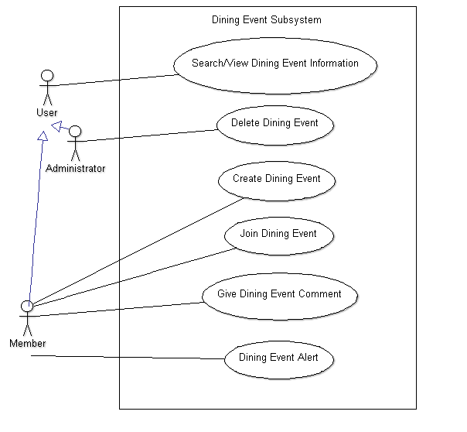

|  |  |
| --- | --- |
| Use case name | Search/View Dining Event Information |
| Use case ID | DES-001 |
| Super use case | - |
| Actor(s) | Administrator, Member |
| Brief description | Search and view event |
| Precondition | 1) Login as administrator or member  2) Select dining event on the home page |
| Post-condition | Retrieve information from the database |
| Flows of events | Administrator or member input the information of the event to the search engine |
| Alternative flows and exceptions | 1) If result is found, view event information 2) If result not found, output error message  3) Back to home page |
| Priority | Medium |
| Non-behavioral requirements | - |
| Assumptions | - |
| Issues | - |
| Source | - |

|  |  |
| --- | --- |
| Use case name | Delete Dining Event |
| Use case ID | DES-002 |
| Super use case | - |
| Actor(s) | Administrator |
| Brief description | Delete an event with reason |
| Precondition | 1) Login as administrator  2) Select dining event on the home page  3) After search event  4) Select event that administrator want to delete |
| Post-condition | Deleted event will not exist anymore. |
| Flows of events | 1) Press delete button  2) Write delete reason and number of member point will be deleted  3) The delete reason and number of member point will be deleted will be sent to the event organizer as personal message  4) Enter administrator password and press send and confirm delete button |
| Alternative flows and exceptions | 1) Cancel delete  2) Back to administrator home page |
| Priority | Medium |
| Non-behavioral requirements | - |
| Assumptions | - |
| Issues | - |
| Source | - |

|  |  |
| --- | --- |
| Use case name | Create Dining Event |
| Use case ID | DES-003 |
| Super use case | - |
| Actor(s) | Member |
| Brief description | Member create a dining event for another member to join |
| Precondition | 1) Login as member  2) Select dining event on the home page |
| Post-condition | 1) A dining event is created  2) Member point is added |
| Flows of events | 1) Select create dining event  2) Input all necessary information  3) Submit the information |
| Alternative flows and exceptions | 1) Give up to create a dining event  2) Back to dining event |
| Priority | High |
| Non-behavioral requirements | - |
| Assumptions | - |
| Issues | - |
| Source | - |

|  |  |
| --- | --- |
| Use case name | Join Dining Event |
| Use case ID | DES-004 |
| Super use case | - |
| Actor(s) | Member |
| Brief description | Member join a dining event held by another member |
| Precondition | 1) Login as member  2) Select dining event on the member’s home page  3) Search view/dining event information |
| Post-condition | 1) Join a dining event  2) Alert is sent to member who hold the dining event  3) Member point is added |
| Flows of events | Select join a dining event |
| Alternative flows and exceptions | Back to member’s home page |
| Priority | High |
| Non-behavioral requirements | - |
| Assumptions | - |
| Issues | - |
| Source | - |

|  |  |
| --- | --- |
| Use case name | Give Dining Event Comment |
| Use case ID | DES-005 |
| Super use case | - |
| Actor(s) | Member |
| Brief description | Member give comment of dining event to the member who hold the event |
| Precondition | 1) Login as member  2) Select dining event on the member’s home page  3) Select joint event |
| Post-condition | 1) Select the event that you want to comment  2) A comment is sent to the dining event page  3) Member point is added |
| Flows of events | 1) Select give comment  2) Write the comment  3) Select send |
| Alternative flows and exceptions | 1) Give up to give comment  2) Back to dining event |
| Priority | Low |
| Non-behavioral requirements | - |
| Assumptions | - |
| Issues | - |
| Source | - |

|  |  |
| --- | --- |
| Use case name | Dining Event Alert |
| Use case ID | DES-006 |
| Super use case | - |
| Actor(s) | System |
| Brief description | System send an email to remind you the details of the dining event automatically one hour before the event starts |
| Precondition | 1) Login as member  2) Select dining event on the member’s home page  3) Select dining event alert setting |
| Post-condition | Email is sent |
| Flows of events | Turn on the dining event alert |
| Alternative flows and exceptions | Turn off the dining event alert |
| Priority | Low |
| Non-behavioral requirements | - |
| Assumptions | You can receive the email |
| Issues | - |
| Source | - |

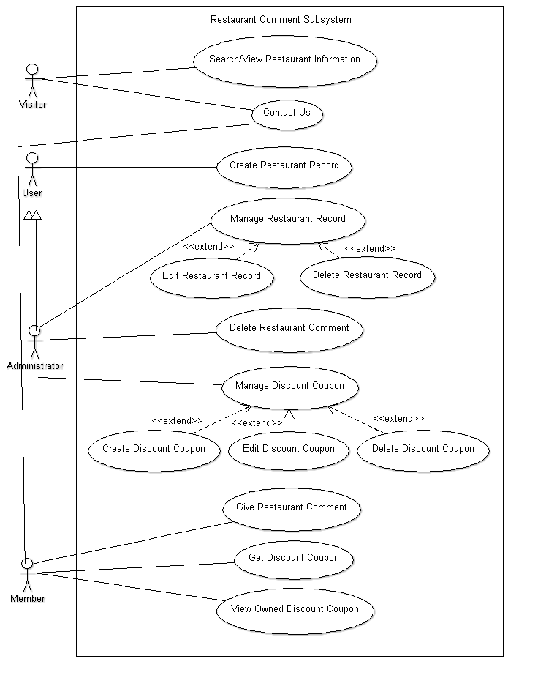

|  |  |
| --- | --- |
| Use case name | Search/View Restaurant Information |
| Use case ID | RCS-001 |
| Super use case | - |
| Actor(s) | Visitor, User (Administrator and Member) |
| Brief description | Both visitor and user can search for restaurant information |
| Precondition | Select restaurant at the home page |
| Post-condition | Retrieve information from the database |
| Flows of events | Visitor on user input the name of the restaurant to the search engine |
| Alternative flows and exceptions | 1) If result is found, view the restaurant information 2) If result not found, output error message and view other restaurant information  3) Back to home page |
| Priority | High |
| Non-behavioral requirements | - |
| Assumptions | - |
| Issues | - |
| Source | - |

|  |  |
| --- | --- |
| Use case name | Create Restaurant Record |
| Use case ID | RCS-002 |
| Super use case | - |
| Actor(s) | User (Administrator and Member) |
| Brief description | Input restaurant information for record |
| Precondition | 1) Login as administrator or member  2) Select restaurant at the home page |
| Post-condition | 1) A restaurant information is created  2) Member point is added |
| Flows of events | 1) Select create restaurant record  2) Input all necessary information  3) Submit the information |
| Alternative flows and exceptions | 1) Give up to create a restaurant record  2) Back to restaurant |
| Priority | High |
| Non-behavioral requirements | - |
| Assumptions | - |
| Issues | - |
| Source | - |

|  |  |
| --- | --- |
| Use case name | Edit Restaurant Record |
| Use case ID | RCS-003 |
| Super use case | - |
| Actor(s) | Administrator |
| Brief description | Administrator can edit restaurant information |
| Precondition | 1) Login as administrator  2) Select restaurant at the home page  3) Select search restaurant information |
| Post-condition | A restaurant’s information is change |
| Flows of events | 1) Select edit restaurant record  2) Input all necessary information  3) Submit the information |
| Alternative flows and exceptions | 1) Give up to create a restaurant record  2) Back to restaurant |
| Priority | High |
| Non-behavioral requirements | - |
| Assumptions | - |
| Issues | - |
| Source | - |

|  |  |
| --- | --- |
| Use case name | Delete Restaurant Record |
| Use case ID | RCS-004 |
| Super use case | - |
| Actor(s) | Administrator |
| Brief description | Administrator can delete restaurant record |
| Precondition | 1) Login as administrator  2) Select restaurant at the home page  3) Select search restaurant information |
| Post-condition | A restaurant’s information is deleted |
| Flows of events | 1) Select restaurant that you to delete  2) Press delete button  3) Enter administrator password and press confirm delete button |
| Alternative flows and exceptions | 1) Give up to delete a restaurant record  2) Back to restaurant |
| Priority | High |
| Non-behavioral requirements | - |
| Assumptions | - |
| Issues | - |
| Source | - |

|  |  |
| --- | --- |
| Use case name | Give Restaurant Comment |
| Use case ID | RCS-005 |
| Super use case | - |
| Actor(s) | Member |
| Brief description | Member give comment to a restaurant |
| Precondition | 1) Login as member  2) Select restaurant at the home page  3) Search the restaurant that you want to make comment  4) View the restaurant information |
| Post-condition | 1) A restaurant comment is created  2) Member point is added |
| Flows of events | 1) Select give restaurant comment  2) Write comment  3) Submit the comment |
| Alternative flows and exceptions | 1) Give up to give restaurant comment  2) Back to restaurant |
| Priority | High |
| Non-behavioral requirements | - |
| Assumptions | - |
| Issues | - |
| Source | - |

|  |  |
| --- | --- |
| Use case name | Delete Restaurant Comment |
| Use case ID | RCS-006 |
| Super use case | - |
| Actor(s) | Administrator |
| Brief description | Administrator can delete restaurant comment |
| Precondition | 1) Login as administrator  2) Select restaurant at the home page  3) Search the restaurant that you want to make comment  4) View the restaurant information |
| Post-condition | A restaurant comment is deleted |
| Flows of events | 1) Press delete button next to the comment  2) Enter administrator password and press confirm delete button |
| Alternative flows and exceptions | 1) Give up to delete a restaurant record  2) Back to restaurant |
| Priority | High |
| Non-behavioral requirements | - |
| Assumptions | - |
| Issues | - |
| Source | - |

|  |  |
| --- | --- |
| Use case name | Create Discount Coupon |
| Use case ID | RCS-007 |
| Super use case | - |
| Actor(s) | Administrator |
| Brief description | Administrator can create a discount coupon after restaurant owner approved |
| Precondition | 1) Login as administrator  2) Select discount coupon |
| Post-condition | A discount coupon is created |
| Flows of events | 1) Select create discount coupon  2) Type in necessary information  3) Select submit |
| Alternative flows and exceptions | 1) Give up to create a discount coupon  2) Back to discount coupon |
| Priority | Medium |
| Non-behavioral requirements | - |
| Assumptions | - |
| Issues | - |
| Source | - |

|  |  |
| --- | --- |
| Use case name | Edit Discount Coupon |
| Use case ID | RCS-008 |
| Super use case | - |
| Actor(s) | Administrator |
| Brief description | Administrator can edit a discount coupon |
| Precondition | 1) Login as administrator  2) Select discount coupon |
| Post-condition | The information of the coupon is changed |
| Flows of events | 1) Select the discount coupon you would like to edit  2) Change the information  3) Select submit |
| Alternative flows and exceptions | 1) Give up to edit a discount coupon  2) Back to discount coupon |
| Priority | Medium |
| Non-behavioral requirements | - |
| Assumptions | - |
| Issues | - |
| Source | - |

|  |  |
| --- | --- |
| Use case name | Delete Discount Coupon |
| Use case ID | RCS-009 |
| Super use case | - |
| Actor(s) | Administrator |
| Brief description | Administrator can delete discount coupon |
| Precondition | 1) Login as administrator  2) Select discount coupon |
| Post-condition | A discount coupon is deleted |
| Flows of events | 1) Select the discount coupon you would like to delete  2) Click delete button  3) Enter administrator password and press confirm delete button |
| Alternative flows and exceptions | 1) Give up to delete a discount coupon  2) Back to discount coupon |
| Priority | Medium |
| Non-behavioral requirements | - |
| Assumptions | - |
| Issues | - |
| Source | - |

|  |  |
| --- | --- |
| Use case name | Get Discount Coupon |
| Use case ID | RCS-010 |
| Super use case | - |
| Actor(s) | Member |
| Brief description | Member use his/her member point to buy discount coupon |
| Precondition | 1) Login as member  2) Select discount coupon |
| Post-condition | Get a discount coupon |
| Flows of events | 1) Select the discount coupon you would like get  2) Click get  3) Click confirm payment button |
| Alternative flows and exceptions | 1) Give up to get discount coupon  2) Back to discount coupon |
| Priority | Medium |
| Non-behavioral requirements | - |
| Assumptions | Member have enough member point |
| Issues | - |
| Source | - |

|  |  |
| --- | --- |
| Use case name | View Owned Discount Coupon |
| Use case ID | RCS-011 |
| Super use case | - |
| Actor(s) | Member |
| Brief description | Member can view bought discount coupon |
| Precondition | 1) Login as member  2) Select discount coupon |
| Post-condition | See what discount coupon can be used now |
| Flows of events | Select view owned discount coupon |
| Alternative flows and exceptions | Back to discount coupon |
| Priority | Medium |
| Non-behavioral requirements | - |
| Assumptions | - |
| Issues | - |
| Source | - |

|  |  |
| --- | --- |
| Use case name | Contact Us |
| Use case ID | RCS-012 |
| Super use case | - |
| Actor(s) | Visitor, Member |
| Brief description | Contact the site about business opportunity, e.g. advertisement or coupon, etc. |
| Precondition | - |
| Post-condition | The message is sent to administrator |
| Flows of events | 1) Click Contact on Business  2) Fill in information  3) Send the message |
| Alternative flows and exceptions | Back to home page |
| Priority | Low |
| Non-behavioral requirements | - |
| Assumptions | - |
| Issues | - |
| Source | - |